Task 1 - Getting started with moqups.com account setup and tools overview

1. Create a free account in moqups.com. Follow with the click on the a Create a Free Account. You can get

this screen. Let’s go with Sign up with Google.

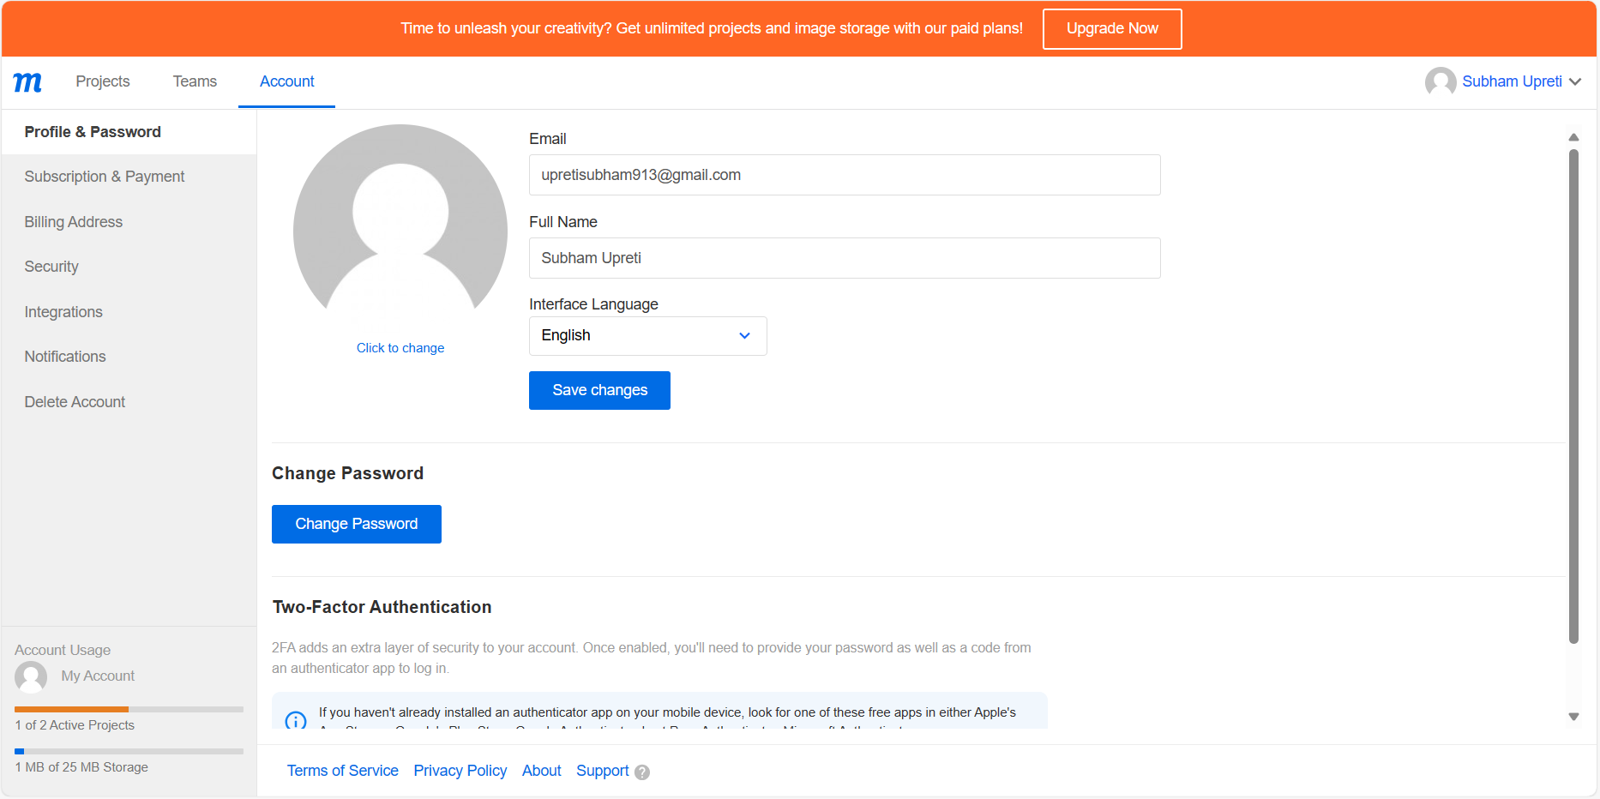

2. You will see this screen. Select Blank Project & Rename as “Wireframe & Mockup”

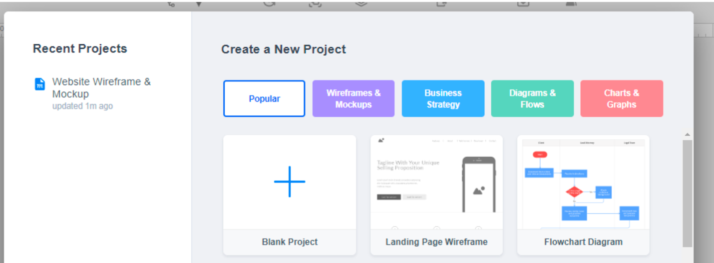

3. You will see this screen

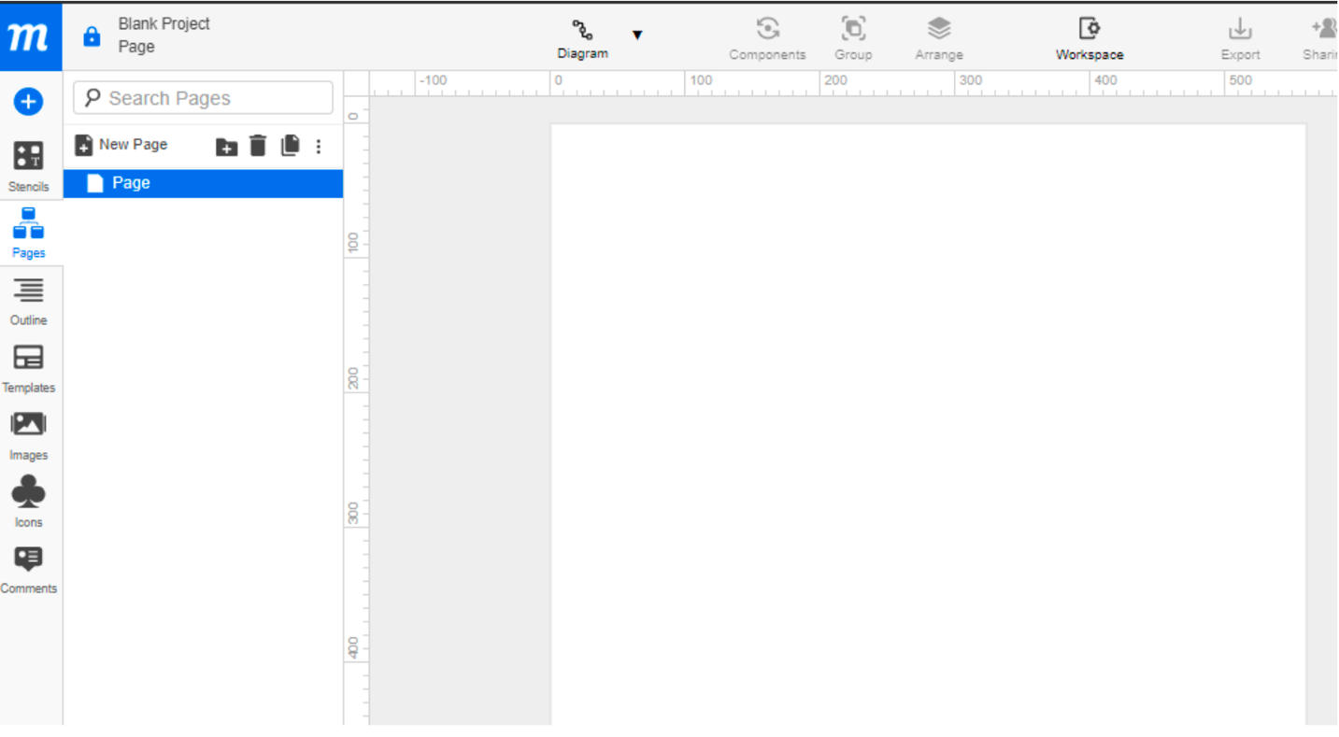

Task 2 – Design the wireframe structure. Use your own creativity.

Moqups Link: https://app.moqups.com/b4mHtbAGDobdwTOFxCa5LJogQyQHz6VW/view/page/ad64222d5

Task 3 – Create a mockup design like your college website’s contact us page. Use your own

creativity for this design.

Moqups Link: https://app.moqups.com/b4mHtbAGDobdwTOFxCa5LJogQyQHz6VW/view/page/a4fd55acf

